Lab4

laknath Gunathilake

January 29, 2020

## Now on your own

let’s consider some of the other variables in the body dimensions data set. Using the figures at the end of the exercises, match the histogram to its normal probability plot. All of the variables have been standardized (first subtract the mean, then divide by the standard deviation), so the units won’t be of any help.

download.file("http://www.openintro.org/stat/data/bdims.RData", destfile = "bdims.RData")  
 load("bdims.RData")  
 mdims <- subset(bdims, sex == 1)  
 fdims <- subset(bdims, sex == 0)

1. The histogram for female biiliac (pelvic) diameter ( bii.di ) belongs to normal probability plot letter **B**.
2. The histogram for female elbow diameter ( elb.di ) belongs to normal probability plot letter **C**.
3. The histogram for general age ( age ) belongs to normal probability plot letter **D**.
4. The histogram for female chest depth ( che.de ) belongs to normal probability plot letter **A**.

.Note that normal probability plots C and D have a slight stepwise pattern. Why do you think this is the case? becuse age and chest depth is slightly right skewed.

.As you can see, normal probability plots can be used both to assess normality and visualize skewness. Make a normal probability plot for female knee diameter ( kne.di ).

qqnorm(fdims$kne.di)  
qqline(fdims$kne.di)

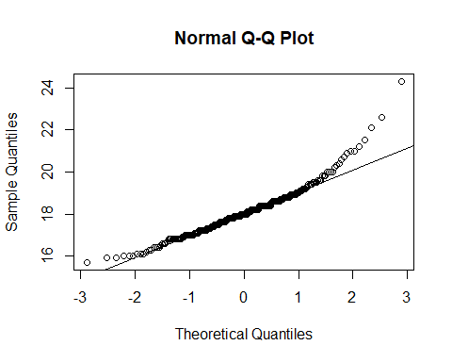

Use a histogram to confirm your findings

hist(fdims$kne.di)

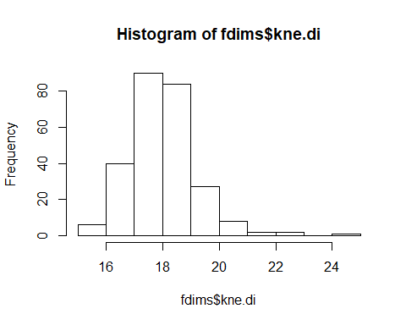

Based on this normal probability plot, is this variable left skewed, symmetric, or right skewed? ***The variable is right skewed***